Value and Reference Types
C# supports two kinds of variable types:
- Value types
These are the built-in primitive data types, such as char, int, and float, as well as user-defined types declared with struct.
- Reference types
Classes and other complex data types that are constructed from the primitive types. Variables of such types do not contain an instance of the type, but merely a reference to an instance.
If you create two value-type variables, i and j, as follows, then i and j are completely independent of each other:
C#
Copy Code
int i = 10;
int j = 20;

They are given separate memory locations:
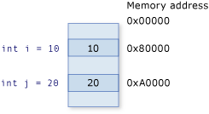
If you change the value of one of these variables, the other will naturally not be affected. For instance, if you have an expression such as the following, then there is still no connection between the variables:
C#
Copy Code
int k = i;

That is, if you change the value of i, k will remain at the value that i had at the time of the assignment.
C#
Copy Code
i = 30;

System.Console.WriteLine(i.ToString()); // 30
System.Console.WriteLine(k.ToString()); // 10

Reference types, however, act differently. For instance, you could declare two variables as follows:
C#
Copy Code
Employee ee1 = new Employee();
Employee ee2 = ee1;

Now, because classes are reference types in C#, ee1 is known as a reference to Employee. The first of the previous two lines creates an instance of Employee in memory, and sets ee1 to reference it. Thus, when you set ee2 to equal ee1, it contains a duplicate of the reference to the class in memory. If you now change properties on ee2, properties on ee1 reflect these changes, because both point to the same object in memory, as shown in the following:
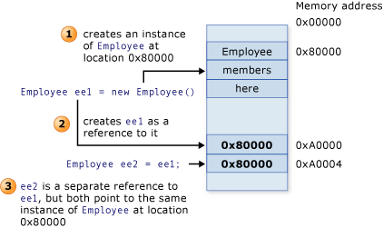
Boxing and Unboxing
The process of converting a value type to a reference type is called boxing. The inverse process, converting a reference type to a value type, is called unboxing. This is illustrated in the following code:
C#
Copy Code
int i = 123; // a value type
object o = i; // boxing
int j = (int)o; // unboxing

Value and Reference Types

class ReferenceType
{
public int X;
}

struct ValueType
{
public int X;
}

ReferenceType ref1 = new ReferenceType();
ValueType val1 = new ValueType();

ref1.X = 5;
val1.X = 5;
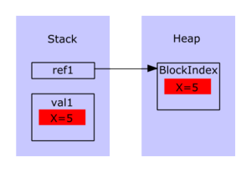
ReferenceType ref2 = ref1;
ValueType val2 = val1;
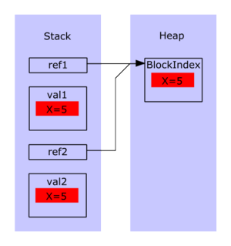
Ref2.X = 8;
Val2.X = 8;
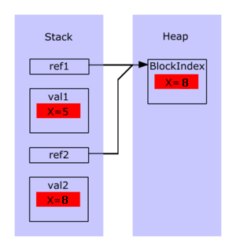

Value and Reference Types

- Variables that are based on value types directly contain values. Assigning one value type variable to another copies the contained value (Therefore, two identical copies of the value are available in memory). This differs from the assignment of reference type variables, which copies a reference to the object but not the object itself (Therefore, the actual value remains same in memory).

- All value types are derived implicitly from the System.ValueType.

- Unlike with reference types, you cannot derive a new type from a value type. However, like reference types, structs can implement interfaces.

- Unlike reference types, a value type cannot contain the null value. However, the nullable types feature does allow for values types to be assigned to null.

- Each value type has an implicit default constructor that initializes the default value of that type. Reference types default to a null reference in memory.

- Value types are allocated on the stack. Reference types are allocated on the heap.

- Value types are of fixed length. Reference types are of varied length.

- Changing the value of one value type does not affect the value of another value type. Changing the value of one reference type MAY change the value of another reference type (When you assign a value type variable to another value type variable, the actual data is copied and each variable can be independently manipulated. When you assign a reference type variable to another reference type variable, the memory address is copied. Therefore, both variables will refer to the same memory address, which means, if you change the value of one variable, the value of the other variable will also be changed).

